|  |
| --- |
|  |
| Report |
| Hotel Management System |
|  |
| Hot Topic [Quarter 2, 2019]  **502.714 – Hot Topic in Software** ****563.783 – Hot Topic in Networking**** Fadi Fayez: Supervisor  Cara Hanson : 11110448  Krishal Kishor: 10925996  Sanjit Birla:120008396 |
|  |

Contents

502.714 – Hot Topic in Software 1

563.783 – Hot Topic in Networking 1

Who did what table 5

1. Introduction 6

1.1 The Accommodation Industry 6

1.2 Our Scope, Aim and Objectives 6

1.3 Measurable Organisational Value(s) (MOVs) 7

2. Literature Review 8

2.1 Research Question 8

2.2 Research Methodology 8

2.3 Introduction 8

2.4 HIBOX Application 9

2.5 KnowCross Application 9

2.6 HotelFriend Application 10

2.7 Cloud beds Reservation System 10

2.8 eZee Front Desk 11

4. Problem Identification 13

5. Methodology 13

6. Resources 13

6.1 Lucidchart 13

6.2 Android Studio 14

6.3 Office 365 14

6.4 Google Docs 14

6.5 Photoshop 15

6.6 Messenger 15

7. Risks and Limitations 16

7.1 Lack of Experience and Skills- 16

Mitigation- 16

7.2 Technology Failure- 16

Mitigation- 16

7.3 Miscommunication- 16

Mitigation- 16

7.4 Time- 16

Mitigation- 16

8. Risk and Mitigations Table 17

9. Design 18

9.1 Use Case Diagram (Manager) 18

9.2 Activity Diagram (Manager) 19

9.3 Activity Diagram steps (Manager) 20

9.4 System Function of Manager 21

9.5 Use Case Diagram (Administrator) 22

9.6 Activity Diagram (Administrator) 23

9.7 Activity Diagram steps (Manager) 24

9.8 System Function of Administrator 25

9.9 Use Case Diagram (Front Desk) 26

9.10 System Function of Front Desk 27

9.11 Housekeeping Use Case Diagram 28

9.12 System Function of Front Desk 29

10. Application design 30

11. Timetable 35

12. Conclusion 36

13. References 37

Figure 1: Who Did What 5

Figure 2: HIBOX website 9

Figure 3: Know Cross 9

Figure 4: HotelFriend 10

Figure 5: Cloud beds Reservation System 10

Figure 6: eZee Front Desk 11

Figure 7: Comparison Table of different applications 12

Figure 8: (Lucidchart, 2019) 13

Figure 9: (Android Studio, n.d.) 14

Figure 10: (Microsoft, n.d.) 14

Figure 11: (Microsoft, n.d.) 14

Figure 12: (Stratel, n.d.) 14

Figure 13: . (Google, n.d.) 14

Figure 14: (Fred the Oyster, 2014) 15

Figure 15: (Facebook, 2019) 15

Figure 16: Risk and mitigation table 17

Figure 17: Manager Use Case Diagram 18

Figure 18: Activity Diagram (Manager) 19

Figure 19: Activity Diagram Steps 20

Figure 20: System Function of Manager 22

Figure 21: Use Case Diagram Admin 22

Figure 22:Activity diagram Admin 23

Figure 23: Steps for the Admin within the system 24

Figure 24: System Function of Manager 25

Figure 25: System Functions of front desk 27

Figure 26: System Function of Front Desk 29

Figure 27 Client Dashboard 30

Figure 28: Manager Dashboard 30

Figure 29: Housekeep Dashboard 31

Figure 30: View assigned rooms 31

Figure 31: Housekeeping activity screen 32

Figure 32: Updated Screen 32

Figure 33: Front Desk Dashboard 33

Figure 34: Front Desk View all room 33

Figure 35:Assigning rooms 34

Figure 36: Log out Screen 34

Figure 37:Ghantt Chart 35

# Who did what table

Figure : Who Did What

|  |  |
| --- | --- |
| **Team Member** | **Tasks** |
| Krishal (Text colour – Purple) | * Team Member. * Documentation. * Literature Review. * Problem Identification. * Use case diagram. * Activity diagram. * Activity Table. * Logo of the Company. |
| Sanjit (Text colour – Blue) | * Literature Review. * Presentation. * Conclusion. * Risks and Mitigations. * Use case diagram. * Activity diagram. * Activity Table. |
| Cara (Text colour - Pink) | * Introduction. * Methodology and Resources. * Gantt chart. * Coding * Data base. * Design of the App. |

### 

# Introduction

## The Accommodation Industry

The accommodation industry is quite large on a global scale. People are forever coming and going, whether it is for vacation or for business, and there will always be a demand for accommodation for those who are temporarily visiting a location. This directly influences the demand for Housekeepers – staff who clean rooms after they have been used for the room to be fit for use by another customer. In small-to-medium accommodation businesses, communication can often be a bit of a struggle between Housekeeping and Front Desk staff, generally requiring in-person communication in order to assign a room that requires cleaning, and it can take a lot of time bringing two busy people together for information to be passed between the pair.

## Our Scope, Aim and Objectives

Having identified that a lot of time can be lost between Front Desk and Housekeeping while relaying information, we saw an opportunity to create a subscription-based android application that will aid in the communication between Front Desk and Housekeeping staff members, removing the need for face-to-face relaying and will essentially save time – which is our aim; To save time between Housekeeping and Front Desk staff members.

As we have limited time to work on our application, we have been very selective as to what our objectives should be while keeping in mind as to what future features could be incorporated into our android application.

Our objectives for our application are:

1. For the application to have a UI which will be easy enough for staff - of all ages - to find easy enough to use while minimizing distractions as much as possible.

2. The application must have a clear display of all rooms and their status for Front Desk, which they can then assign a certain room to a Housekeeping staff member to clean.

3. The application must display all rooms assigned to a Housekeeping staff member, where they can then change the status of the room to ‘Currently Cleaning’ or ‘Cleaned’.

## Measurable Organisational Value(s) (MOVs)

Operational Impact is one of our main areas of impact, as the application will allow accommodation staff to change how they communicate required tasks. We can safely say, through observation, that each staff member that manually reports a rooms status can roughly take 10 minutes a day in doing so. It might not look like much, but any smart businessman/businesswoman can easily identify how a few minutes each day can accumulate over the week, the month and year per staff member working for them - and a loss of time is a loss of money. This brings encouragement for those experiencing these issues in to finding a better solution, to which we offer via our android application.

This leads us into another area of impact that affects us directly – finance. As our application is subscription based, we’ll see an income head our way. We’ve set our monthly subscription price to $99NZD, including GST – and for one client, that’d total up to $1,188NZD for a year. We aim to have 150 clients by the end of the first year of our launch, though there is no real way to calculate how much that’d bring in as we won’t be able to effectively predict when throughout the year they’d join. However, with the 150 carried over into the second year of our launch, that’d pull in $178,200* – without calculating in any new clients we may have gained along the way. As you can see, we may start off slow in the beginning, but over time we will pick up and earn more revenue.

* This figure does not consider taxes and other costs we will have, such as maintenance.

# Literature Review

## Research Question

Can we create an easy to use housekeeping reporting application which will assist small to medium size accommodation suppliers to reduce waste of time and, hence reducing the cost?

## Research Methodology

Research Methodology used for this research is Qualitative Research as this provided us best results as this methodology allows us to look at prior case studies and collecting data from other means such as articles and previous work, hence the information is close to accurate and reliable.

# Introduction

(Ivanović, 2008). In most accommodation industry the most significant cost of running an accommodation tends to be associated with human resources. In most hotels and motels, the payroll is the single biggest cost, whereas the in a restaurant and or a bar it tends to be second, to cost of materials, such as food and beverages. In small accommodation suppliers line manager tends to be the owner that manages the staff whereas in larger industry the line manager will be assisted by the staff management issued by human resource and or personnel managers.

As the accommodation industries worldwide are a very large industry therefore it is fair to ensure that a literature review is conducted. This Literature review will revolve around the accommodation industries processes in housekeeping and their PMS (Property Management System). We will be comparing other systems which are available in the market which utilize either android based application and or application which has the features to assists the accommodation supplier with housekeeping reporting to the front desk and looking at features on the bigger platform to try and utilize them in more user friendly manner.

# HIBOX Application

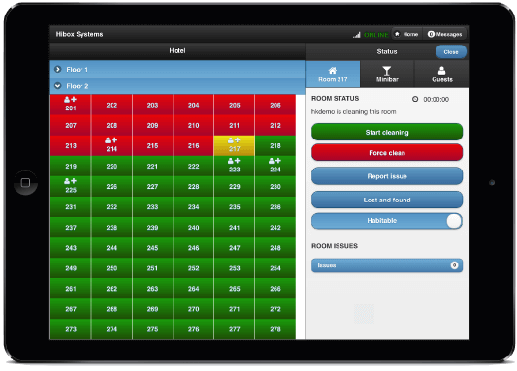

(HIBOX, 2019). HiBox is a multi-platform application thus provides advanced interactive information and entertainment solutions for customer and commercial application. One of which is the Hibox hospitality which provides the customers with user interface to better manage the housekeepers and is integrated to PMS (Property Management System) which has been created by Staffan Granholm CEO and the team of the company. This application is subscription based, this allows small companies to afford it and to use it and to see how or if it benefits the company. Application features consists of allowing housekeeping staff to report the usage of mini bar within the units and that information automatically registers it to the PMS therefore allows the front desk to view it. The application also allows housekeepers to take photos and report any broken or lost and found items within that room so the front desk is aware of items lost or damages done by the guest so the front desk can chase them up regarding lost items or charge them for damages to the property. There system operates on the browser therefore you just need a provided URL and login with your credentials and your basically ready to use the program.

Figure 2: HIBOX website

# KnowCross Application

(Knowcross, 2019) Knowcross was founded in the year 2002 which prides itself to be quote “Help improve guest service and enhance staff productivity and increase guest loyalty” which this company stands by. This company spans to more than 40 countries and provides 24/7 support. The company offers Saas (Software as a service) therefore it mean that the companies services are cloud based and that it’s a subscription based software and can be accessed online Via browser, which mean that the software doesn’t have to be installed on any computer and therefore doesn’t require any extra hardware requirements to run this application however they do provide an option to clients to have a hard copy of the software if the customer requires it. Know housekeeping does also provide easy to use application on android and IOS devices hence making it much easier to the user built into the application has options to select Multilanguage interface to reduce language barrier. This application also can contact to your PMS therefore the front desk will be aware of rooms which are dirty, clean, inspected. Know Housekeeping applications automatically allocated rooms and will prioritization rooms be depending on guest requests of early check-in. Know Housekeeping will also look at your linen count and will report to front desk to order more linen and will calculate depending on how many check out of how much linen is required.

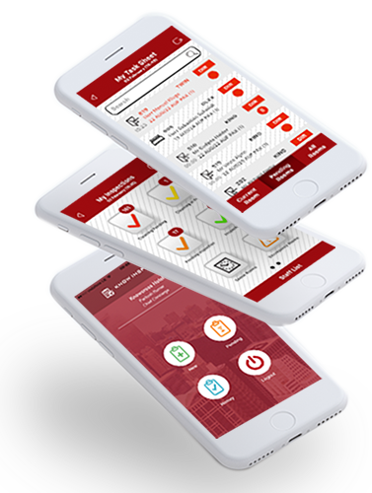

Figure 3: Know Cross

# HotelFriend Application

(HotelFriend AG, 2019)Hotel friend provides multiple management application such as [Hotel Management System](https://hotelfriend.com/products), [Central Reservation System](https://hotelfriend.com/central-reservation-system), [Property Management System](https://hotelfriend.com/hotel-pms), [and Software for Small Hotels](https://hotelfriend.com/software)

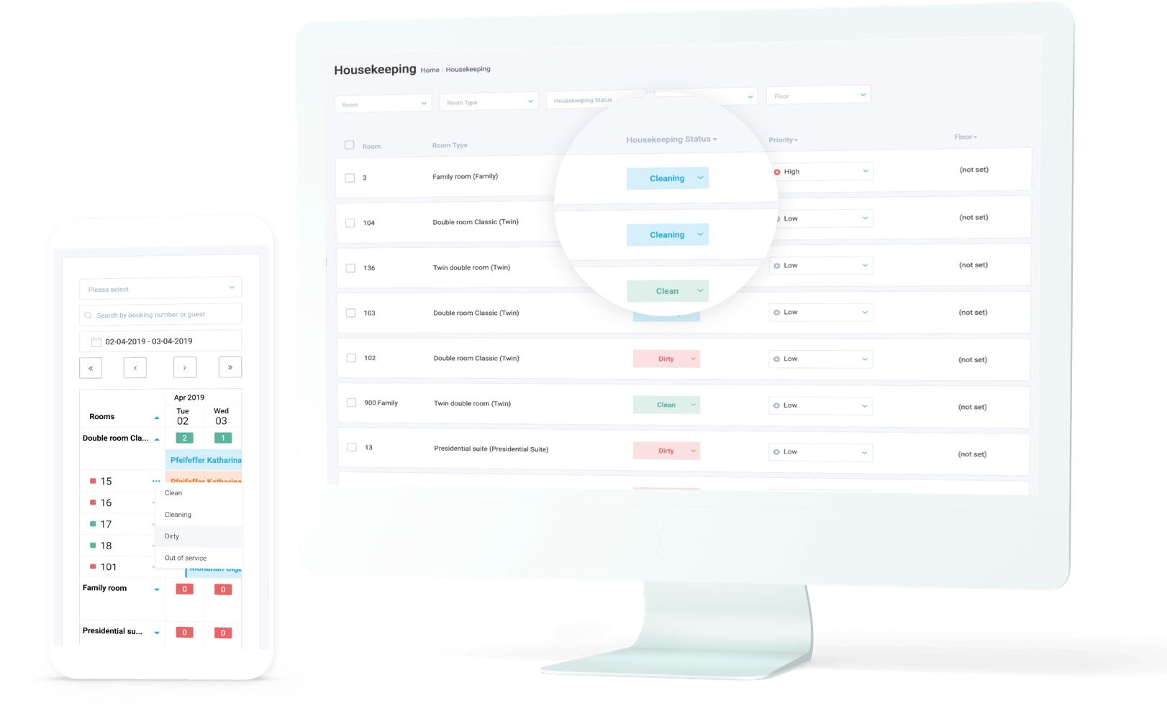

Figure 4: HotelFriend

[Deal, Package Composer](https://hotelfriend.com/deal-manager), [Mobile concierge app](https://hotelfriend.com/hotel-mobile-app)

[Hotel Guestbook Mobile App](https://hotelfriend.com/b/mobile-app-guestbook), [Room Service Mobile App](https://hotelfriend.com/b/hotel-room-service-mobile-app) and also [Hotel Website Development](https://hotelfriend.com/b/hotel-website-development) applications. Hotel Housekeeping System is one of their most requested software by hotel industries as this application offers housekeeper with a list of rooms that needs to be cleaned and also provides live update on rooms that have been prioritized by the front desk this is normally done to adhere to customers’ requests such as they requested a early check in or they have requested a service early during the day. Hotel Friend housekeeping application also provides housekeeper to report if the room has been cleaned or requires something to be fixed within the room and or if the room is dirty and will require more time to get the room cleaned, therefore allowing the front desk to arrange repairs and or to allow more time for the housekeeper to complete their rooms.

# Cloud beds Reservation System

Cloud beds Reservation System – This app is multi task that can connect to hundreds of channels from your property such as booking.com and Orbitz and it allow guests to make direct booking from their desktop, phone and through Facebook so, this app so handy and gives good impact for small business e.g. - Hotel and Motel.

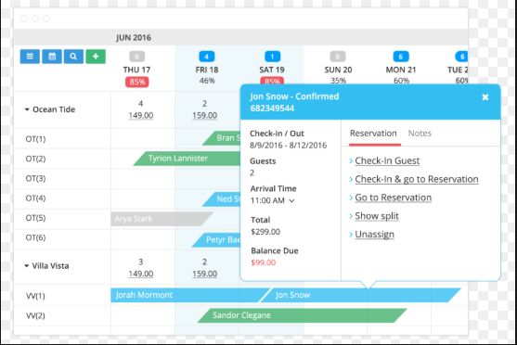

Figure 5: Cloud beds Reservation System

* Easy to use and 24/7
* Customer support online
* Credit card system integrated by third parties.

### What we would like to improve or add in the future for our system.

* Online support
* We would add payment from credit card in the future.

# eZee Front Desk

eZee Front Desk **–** App is mainly used by small lodge, hotel and motel and company claim that app is using in 140 countries all around the world and more than 1 million transaction in a day and across hotel management property resulting in 90,000 room manged and 70,500 users by eZee Front Desk app.

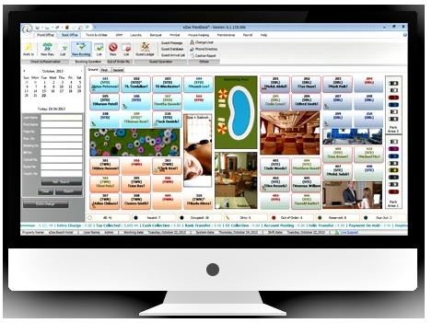

Figure 6: eZee Front Desk

* Receive application report on phone and tablets.
* Event Management.
* Self-service check in Kiosk.

What we would like to improve or add in the future for our system.

* We could add any language pack based on Client majority.
* Online help.

1. Comparison Table

|  |  |  |  |  |  |
| --- | --- | --- | --- | --- | --- |
| Software | Key Features | Customer | Support | Pricing and Security | Rating |
| HIBOX Smart Room for your Staff | * Dynamic Task Allocation * Reporting * Centralized Management * Cleaning Maintenance * Reporting | * Small Business * Medium class Business | * Online support * Android | * Hibox Evacuator brings IT security of the emergency messaging to a new level by introducing SSL encryption on the network connection and NFC / RFID or PIN code authentication for the user interface. | 3.5/5 |
| KnowCross | * Lost and Found * Late Check Out * Real Time Tracking * Print Old Record * Open API * Mobile Access on Any device * Prevention and maintenance module and many more lists go on | * Small   Business  Medium Business   * Large Enterprise Business | * Online Support * Android Support | * Subscription based | 4/5 |
| Cloud Beds | * Reservation Manger * Auto Room Mapping * Currency Conversation * Dashboard * Custom Payment Option * Dashboard * Rooms and Bed Assignment | * Large Enterprise * Mid-Size Business * Small Business * Free Trail Available | * Online Support 24/7 * Android * No Credit card Required | * Subscription based * Multi Factor Authenticity Option * Retention of Customer data after Service Cancellation | 4/5 |
| Ezee Front Desk | * Reservation Management * Online Booking * Rate and Room Availability Features * Accounting Feature * Email Automation * House Keeping Management * Pont Of Sale * Review Management | * Small Business * Medium class Business * Large Enterprise | * Android * Window * iPhone and iPad * Online Support | * Quote based * Ezee Front desk is a quote-priced system, which means that each client receives a specially tailored enterprise package that meets their specific needs. * Free trail | 3.5/5 |

Figure : Comparison Table of different applications

# Problem Identification

The problem that was identified by the Literature Review that was conducted found that majority of applications used within the accommodation industries are mainly for larger corporate and hence costs for those applications are not affordable for small industries such as Backpackers and motels and other smaller accommodation industries. Applications that we are going to create will allow us to tap into the smaller industries by creating a small, simple and affordable system. We also have seen that most of the companies offering cloud based database for the systems however we believe that providing an application on a physical platform will assist small business as getting a cloud based service will contribute to costs to the company and therefore won’t be interested in the software.

# Methodology

The methodology we will be using throughout this project will be that of the Agile methodology – more specifically, the Agile Scrum methodology, as we have limited time and require flexibility to change parts of our project as it goes through development. This means we will have our product owner (supervisor in this case), work closely with us - the team - to prioritize what needs to be accomplished in the next ‘sprint’ (Blueprint, n.d.).

# Resources

# Lucidchart



Figure 8: (Lucidchart, 2019)

Lucidchart has been an important tool for us to use to create our diagrams, such as our ERD for our database design

# Android Studio



Figure 9: (Android Studio, n.d.)

Android Studio’s IDE will be our main tool used throughout our conceptualization phase. We’ll be creating our application using Java, as it’s the most familiar with our developer.

# Office 365

Three programs provided from Microsoft Office 365 has been and will continue to be used throughout this project. Word will be predominantly for documentation and proposals, PowerPoint for our presentations, and Project used for the creation of our Gantt Chart – which will be followed closely for scheduling throughout the project.

Figure 10: (Microsoft, n.d.)

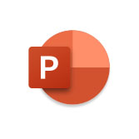

Figure 11: (Microsoft, n.d.)



Figure 12: (Stratel, n.d.)

# Google Docs



Figure 13: . (Google, n.d.)

We have created a Google Docs via our group on Canvas, where we could throw up our notes throughout the project, which allowed everyone to be able to proof-read each other’s work and assess where everyone was and what needed to be done.

# Photoshop



Figure 14: (Fred the Oyster, 2014)

Photoshop was used only for our UI design for the application, as it provided layers that made edits a lot easier as they were required.

# Messenger



Figure 15: (Facebook, 2019)

Messenger is used between the team for communication purposes.

# Risks and Limitations

* 1. Lack of Experience and Skills-Lack of experienced our team has only one software developer and required to create a Hotel reservation app its big job for us as a team to produce app and that’s going to be challenging. We simply lack expertise but we both Networking student will try our best to help our Developer out during these 8 weeks to make efficient app for our staff.

Mitigation- Discussion with senior Software developer and learning from them, what need to be done on time as of Knowledge side it doesn’t matter who’s is younger or older it all about asking and doing own research putting effort so, I think If developer could do that it would be another chance to gain some more experience and adding skills.

* 1. Technology Failure-If technology is failing could put huge failure impact on project as we all know system could be fail at any time and that cause a massive loss to our group through technology as technology has number of good reason but never know what could have happened to machine in couple of second because all work is going to be save on our computer.

Mitigation- All we can do to have a backup on a different computer at the same while doing a project that’s the only way we could save our work or on Google Drive.

* 1. Miscommunication- Bad communication is the biggest thing especially when doing a project work with different members as we all know need to know what the task are of another member. Improper communication could lead to fail project or Assignment and give unnecessary problem that we don’t want especially, when you have only 8 weeks to create an app so, Communication must be good between members.

Mitigation- Having meeting with your group members exclude class meeting trying to make a time for them and that would help everyone to lead successful project

* 1. Time- Our group is very inexperienced regards of creating a hotel reservation app for our group and only have 8 weeks to do so. We could be fall behind in this project due to lack of experience and we never done like this before so, it’s so new for us that could reach failure to reach our milestone or could be fail the project.

Mitigation- It’s important that we distribute our task between members so, everyone has fair chance to do during time given as time is super crucial for this project because nobody want to fail this course so, every single member need to use time very efficiently to have nice impact on our project.

|  |  |
| --- | --- |
| **RISK** | **MITIGATIONS** |
| **Lack of Experience and Skills**   * Only one software Developer. | * Discussion with senior Lecturer. * Need to do more research by yourself. |
| * Required to create a Hotel app. | * Asking question |
| * 8 Weeks of to make efficient app. |  |
|  |  |
| **Technology Failure**   * Computer having problem either Software wise/Hardware. * It could make our group fail. | * Need to do back up on External Hard Drive. * Google Drive. |
|  |  |
| **Miscommunication**   * Improper Communication between group members. | * Meeting with your Group members. * Meet after the class for better outcome. |
| * Task need to be divided equally. |  |
| * Try to know your team member. |  |
|  |  |
| **Time**   * Only 8 Weeks to create a app. * Time is crucial. | * Every member needs to use time wisely. * Describe task so, everyone has fair chance to do their task in time. |
| * Give values to time or that would lead to failure project. |  |

Figure 16: Risk and mitigation table

# Risk and Mitigations Table

# Design

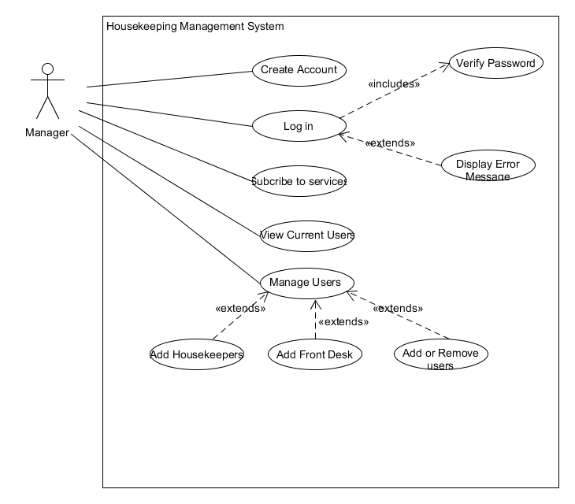

Figure 17: Manager Use Case Diagram

# Use Case Diagram (Manager)

Manager interaction with the housekeeping application, the manager firstly needs to create and account and log in and subscribe to the services in order to use the application.

# Activity Diagram (Manager)

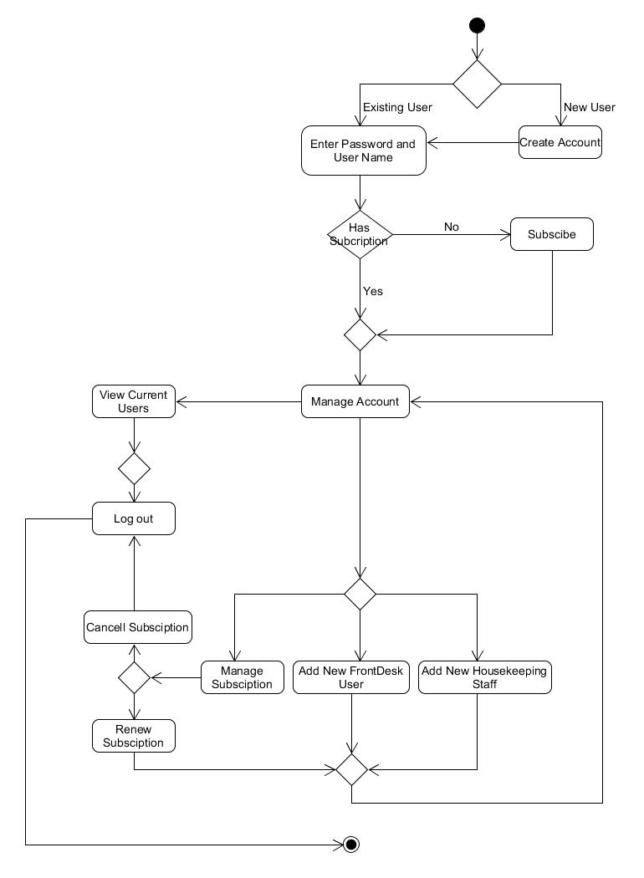

Figure : Activity Diagram (Manager)

# Activity Diagram steps (Manager)

|  |  |
| --- | --- |
| 1 | If the manager is a new user then they need to create a account |
| 2 | IF Manager is an existing they need to first log in to the system |
| 3 | IF the manager doesn’t have subscription the manger need to subscribe to the services |
| 4 | IF the manger has a subscription then the manager can add or remove users |
| 5 | View existing users |
| 6 | Manage Subscription |
| 7 | Add new front desk staff |
| 8 | Add New Housekeeping Staff |
| 9 | Renew or cancel subscription |
| 10 | Log out |

Figure : Activity Diagram Steps

# System Function of Manager

|  |  |  |  |  |
| --- | --- | --- | --- | --- |
| Activity | Input | Process | Output | User |
| Creating Account | * User Name * Password * Email | Add Username and password, Email to database | Send Email to confirm user | User gets confirmation via email of the account |
| Subscribe to service | * Name of accommodation * Number of rooms * Enter payment option | Add to users database and reconfirm user input | Send email to confirm payment | Manager can add users (Front desk , Housekeepers) |
| Add Housekeepers | * First and last name * Contact details * Allocate ID and password | Add to database the user name and ID | Display user details and position | Housekeeper Staff can log in to the interface |
| Add Front desk | * First and last name * Contact details * Allocate ID and password | Allocate information to database with user name, ID and position | Display user Details and position | Front desk can view housekeepers and rooms in the accommodation |
| Renewal or cancellation of Service | * Login With user name and password | Select manage account and select renew or cancel service | Either cancel services with take you to main screen,  Renew will take you to main screen. | Manager will get an email confirming the changes (Renewal or Cancellation) |

Figure : System Function of Manager

# Use Case Diagram (Administrator)

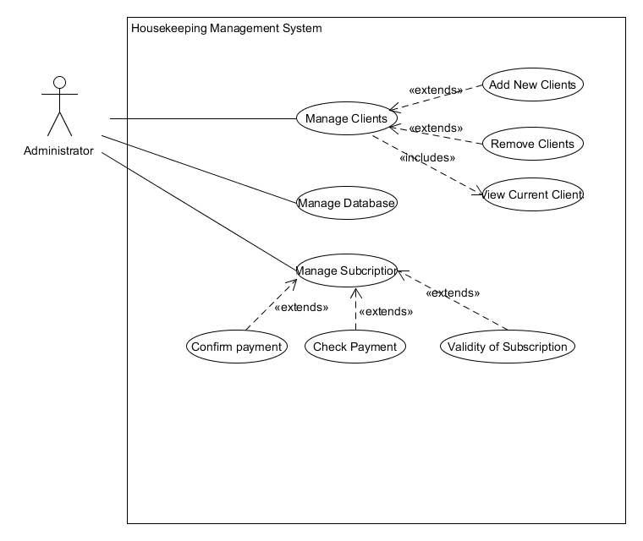

Figure : Use Case Diagram Admin

Administrations interaction with the housekeeping application is to ensure that all subscribed clients and their information is kept safe and also to add new clients on to the services provided by us.

# Activity Diagram (Administrator)

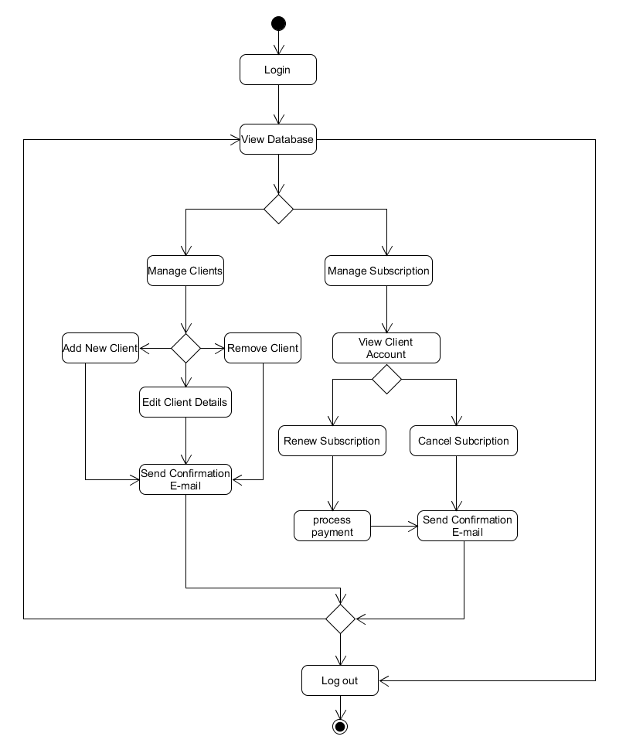

Figure :Activity diagram Admin

# Activity Diagram steps (Manager)

|  |  |
| --- | --- |
| 1 | Administrator needs to log in to the portal |
| 2 | View Database |
| 3 | Manage Clients |
| 3.1 | Add new Clients |
| 3.2 | Edit Client Details |
| 3.3 | Delete Client Details |
| 4 | Send Email Confirmation of Changes |
| 5 | View Database |
| 6 | Manage Subscription |
| 7 | View Client Details |
| 8 | Renew Subscription |
| 8.1 | Process Payment |
| 9 | Send Email confirmation |
| 10 | If cancel subscription |
| 11 | Send email to client of the changes |
| 12 | View Database or log out |

Figure : Steps for the Admin within the system

# System Function of Administrator

|  |  |  |  |  |
| --- | --- | --- | --- | --- |
| Activity | Input | Process | Output | User |
| Log in | * User Name * Password | Enter Username and password | Administrator logged in | Admin can view database |
| Add new Clients | * Name of accommodation * Name of client * Contact details * Email ID | Add to users database and reconfirm user input | Send email to confirm | Admin can either log out or move to manage Subscription |
| View Client Account | * Enter Client name * Enter Clients Accommodation ID | Find on data base | Display Clients Account | Admin can cancel subscription or renew |
| Renew subscription | * On clients account process payment and allocate payment to account | Save Input to database | Send email confirming payment | Client receives receipt of payment |
| Cancellation of Service | * Clients requests cancellation of service | Select account and select cancel service | Cancel services confirmation email. | Client will receive email of cancellation. |

Figure : System Function of Manager

# Use Case Diagram (Front Desk)

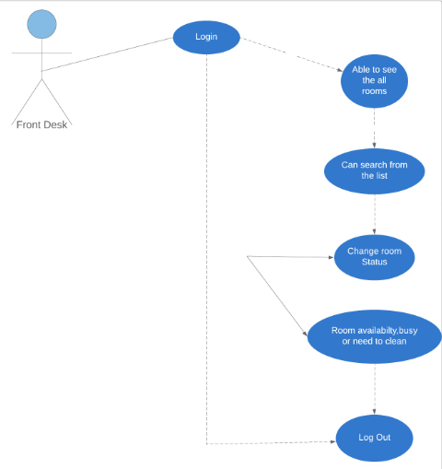

# System Function of Front Desk

|  |  |  |  |
| --- | --- | --- | --- |
| Activity | Input | Process | Output |
| Login | User name and Password | It will take you to the next page. | Able to see the all rooms. |
| Rooms Status | Can search from the list. | Customer can choose what kind of room or how big room he/she is looking for. | Then will be able to see the status. |
| Availability of the rooms | Same login and password as used before for the Front Desk in the beginning. | After using username and password you will able to check availability of the rooms, need to clean or busy. | Then you can act behalf on status and log out later. |
| Current users | Manger will Add Front Desk and Housekeeper to the list. | Then Front Desk can see the current users. | Manger can Add or Remove user. |

Figure : System Functions of front desk

# Housekeeping Use Case Diagram

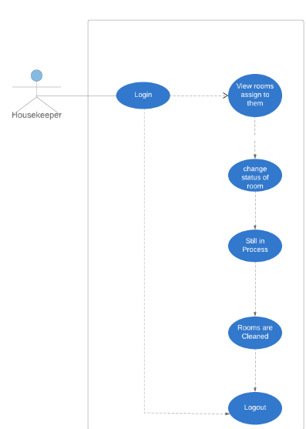

# System Function of Front Desk

|  |  |  |  |  |
| --- | --- | --- | --- | --- |
| Activity | Input | Process | Output | User |
| View Review Assign to Them. | Need to login | User name and Password. | Then able to see rooms | Log out |
| Change Status of Rooms. | How many rooms need to be cleaned or haven’t been cleaned yet. | Telling us on the app about rooms e.g.-processing and cleaned. | What rooms has been cleaned and how many are in the processing. | Maintain inventory and check regular furniture to make sure in the good shape. |
| Rooms Checking | User name and Password | Need to check through the app about client whether customers are in or out. | Check out | Log out |
| House keeper | Log in | User name and address | What has been going on regarding rooms. | what rooms has been cleaned out by who? |

Figure : System Function of Front Desk

# Application design

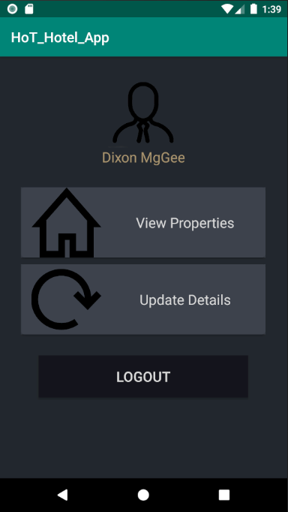

Figure 27 Client Dashboard

* 1. The Dashboard that appears for the client/owner of Accommodation business. None of these listed items are functional in current version, though they can log in/out.
  2. The Dashboard for a manager of an accommodation business. None of these listed items are functional in current version, though they can log in/out.

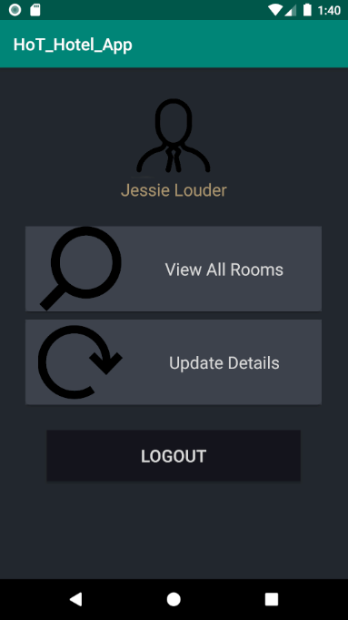

Figure 28: Manager Dashboard

* 1. Dashboard for Housekeeper. ‘Report Damage’ and ‘Update Details’ currently unavailable. Can log in/out and can click on ‘View Assigned Rooms’, which will lead them to a list of all rooms assigned to them (in next image).

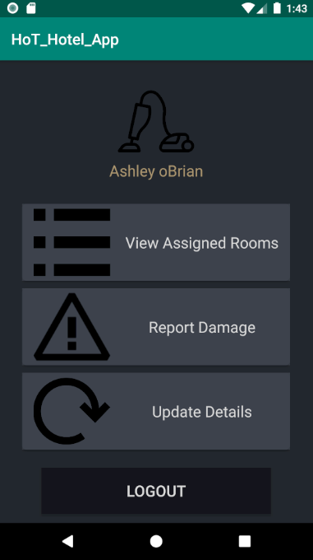

Figure 29: Housekeep Dashboard

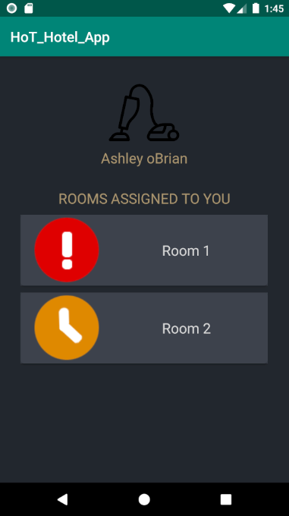

Figure 30: View assigned rooms

* 1. From ‘View Assigned Rooms’ – shows entire list of rooms assigned to user that requires cleaning. Can select any room to change its status (such as ‘Needs Cleaning’, ‘Currently Cleaning’, ‘Cleaned’) – will lead to update status page (shown in next image).
  2. Both Housekeeper and Frontdesk Users can see this activity when they select a room from their respective room list activities and will see their own name and related icon. When room is updated, user will see an alert before being redirected to their respective dashboards (as shown in next image).

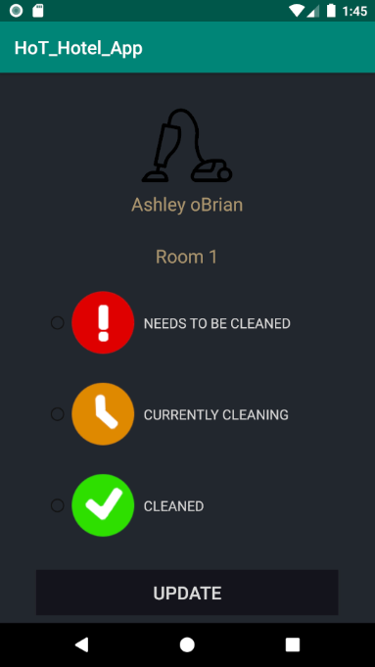

Figure : Housekeeping activity screen

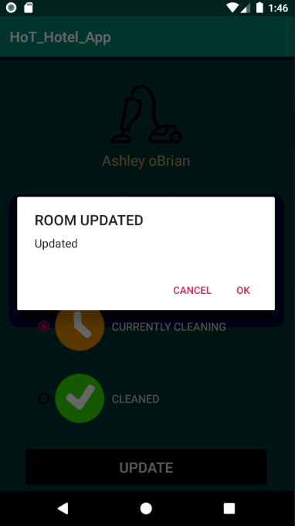

Figure : Updated Screen

* 1. When room is updated either by housekeeper or frontdesk user, they will see this notification before being redirected to their dashboard.
  2. Front Desk’s dashboard. ‘View Damage Reports’ currently unavailable. Able to select ‘View All Rooms’, ‘Assign Room’ and to log in/out.

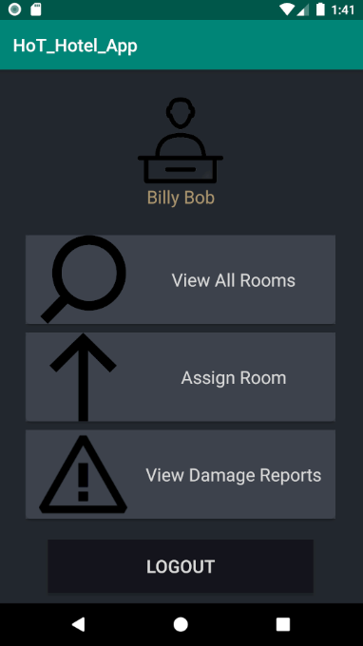

Figure : Front Desk Dashboard

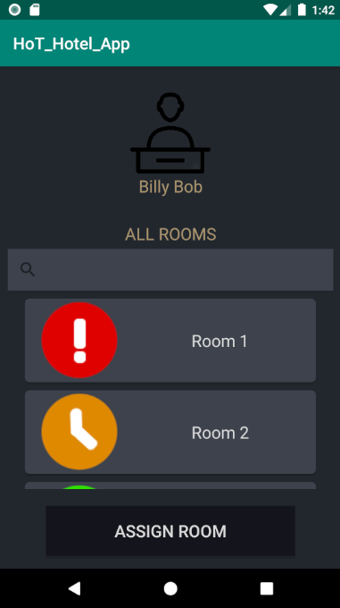

Figure : Front Desk View all room

* 1. When front desk selects ‘View All Rooms’ from their dashboard, they will see this. Unable to search through rooms, but like Housekeeper can select a room to be redirected to ‘Update Room Status’ Activity.
  2. Front Desk will be redirected here whether they select ‘Assign Room’ on their dashboard, or ‘Assign Room’ Button in their ‘View All Rooms’ Activity. Desired to have a drop-down of respective housekeeping staff, though due to time just hard-coded in sole housekeeper UserID and made textfield un-editable. No verification currently exists in this to check room number is properly inserted, though if using proper room number it will update in the DB, show update notification, and redirect frontdesk user to their dashboard.

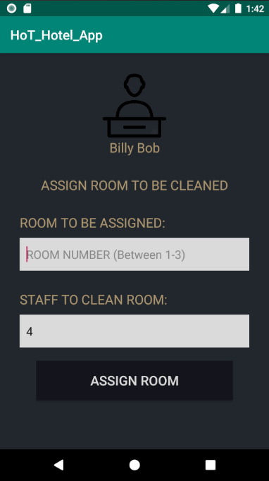

Figure :Assigning rooms

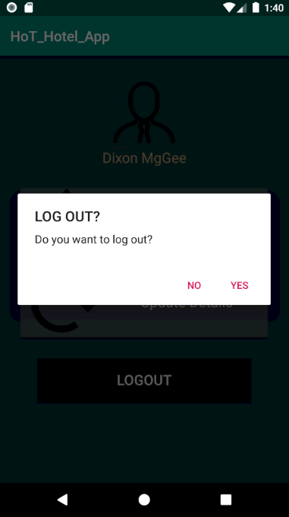

Figure : Log out Screen

* 1. All Users will see this whether they click ‘logout’ button or click back while on their dashboards.

# Timetable

**Breakdown:** Cara – Development

Krishal and Sanjit – Research and Documentation

Figure 37:Ghantt Chart

# Conclusion

As we our young developer trying to achieve our goal that have given to us by our Lecturer and we still believe our group has potential to succeed in this project and have nice celebration afterwards as developer we need to push our self to achieve something in the industry to make an impact for future generation to m make their lives better.

# References

1. Adobe. (n.d.). Photoshop Logo [Logo]. Retrieved from <https://en.wikipedia.org/wiki/Adobe_Photoshop#/media/File:Adobe_Photoshop_CC_icon.svg>
2. Android Studio. (n.d.). [Logo]. Retrieved from <https://developer.android.com/studio>
3. Blueprint. (n.d.). Agile Methodologies. Retrieved from

<https://www.blueprintsys.com/agile-development-101/agile-methodologies>

1. Facebook. (n.d.). [Logo]. Retrieved from <https://www.messenger.com/>)
2. Google. (n.d.). Google Docs [Logo]. Retrieved from <https://docs.google.com/document/u/0/>
3. HIBOX. (2019). *HI box*. Retrieved 30/05/2019, from <https://www.hibox.tv/Hotel-Housekeeping-System.shtml>
4. HotelFriend AG. (2019). *About US* . Retrieved from HotelFriend: <https://hotelfriend.com>
5. Ivanović, S. &. (2008). *HUMAN RESOURCE MANAGEMENT IN THE HOSPITALITY INDUSTRY.* Croatia.
6. Knowcross. (2019). *About Us*. Retrieved 2019, from KnowCross: https://knowcross.com/
7. Lucidchart. (n.d.). [Logo]. Retrieved from <https://www.lucidchart.com/blog/>)
8. Microsoft. (n.d.). PowerPoint logo [Logo]. Retrieved from <https://www.microsoft.com/en-nz/education/products/office/default.aspx>
9. Microsoft. (n.d.). Word logo [Logo]. Retrieved from <https://www.microsoft.com/en-nz/education/products/office/default.aspx>
10. Stratel. (n.d.). [Logo]. Retrieved from https://www.stratel.com.au/project
11. Taylor, D. (2018, Jan 2nd). *The 11 Most Popular Hotel Management Software Solutions for Small Hotels Compared*. Retrieved from Capterra: https://blog.capterra.com/the-5-most-popular-hotel-management-software-solutions-for-small-hotels-compared/
12. USA, c. C.-(.-1. (2012). *Cloudbeds*. Retrieved from Capterra: https://www.capterra.com/p/158839/Cloudbeds/